EXPLORATORY DATA ANALYSIS (EDA)

Internship Project – Week 3 Deliverable


This Photo by Unknown Author is licensed under CC BY
Prepared By: Mudrika Mishra
Program: PGDM (Business Analytics)
Institute: Jaipuria Institute of Management, Noida
Internship Role: Junior Data Scientist
Project Domain: Agribusiness Data Analysis
Date: October 2026

1. Executive Summary
Exploratory Data Analysis (EDA) is an important stage in the data analytics process because it helps transform raw data into meaningful patterns and insights before predictive modelling or advanced statistical analysis is performed.
This report presents a structured EDA framework for analyzing an agribusiness dataset with the objective of understanding the factors associated with crop yield. The proposed framework covers dataset understanding, descriptive statistics, univariate analysis, bivariate analysis, categorical comparisons, correlation analysis, visualization, anomaly identification, interpretation, and preparation for subsequent predictive modelling.
For practical demonstration, the framework was applied to a cleaned agricultural dataset containing 999,769 observations and 10 variables. The target variable was Yield_tons_per_hectare. The analysis examined environmental variables such as rainfall and temperature, operational variables such as fertilizer and irrigation usage, and categorical variables such as crop, region, soil type, and weather condition.
The exploratory analysis showed that rainfall had a strong positive correlation with crop yield (r = 0.7645). Fertilizer usage and irrigation usage also showed noticeable differences in average yield. In contrast, temperature and days to harvest showed weak or negligible linear relationships with yield, while crop type, region, soil type, and weather condition showed relatively small differences in average yield.
The findings demonstrate how EDA can be used to identify potentially important variables, detect unusual observations, understand distributions, and prepare the dataset for future predictive modelling.

2. Introduction
Agriculture is influenced by several environmental, operational, and geographical factors. Understanding the relationships between these factors and crop production can support better planning, resource allocation, and decision-making.
However, raw agricultural data may contain many variables, different data types, unusual observations, and relationships that are not immediately visible. Exploratory Data Analysis provides a systematic approach for understanding such datasets before developing predictive models.
The purpose of this report is therefore to design a complete EDA approach for agribusiness data and demonstrate how the approach can be applied to a crop-yield dataset.
The analysis focuses on the following broad question:
Which variables in the available agricultural data show noticeable associations with crop yield, and what patterns can be identified before predictive modelling?

3. Objectives of the EDA
The main objectives of the EDA are:
- To understand the structure and characteristics of the agricultural dataset.
- To examine the distribution of crop yield.
- To identify relationships between numerical variables and crop yield.
- To compare average yield across categorical variables.
- To examine correlations between relevant numerical variables.
- To identify potential statistical anomalies and unusual observations.
- To select variables that may be useful for future predictive modelling.
- To communicate findings through clear and interpretable visualizations.
- To translate statistical findings into potential agribusiness insights.
- To establish a reproducible analytical workflow.

4. Dataset Overview
The dataset used for the practical demonstration contains information about agricultural conditions and crop yield.
After data cleaning in the previous stage, the dataset contained:
- 999,769 observations
- 10 variables
- No missing values
- No duplicate records
- Positive crop-yield values
The target variable is:
Yield_tons_per_hectare

Dataset Variables
Variable | Data Type | Description
Region | Categorical | Geographic region of cultivation
Soil Type | Categorical | Soil category
Crop | Categorical | Type of crop cultivated
Rainfall mm | Numerical | Rainfall received in millimeters
Temperature Celsius | Numerical | Temperature in degrees Celsius
Fertilizer Used | Categorical | Whether fertilizer was used
Irrigation Used | Categorical | Whether irrigation was used
Weather_Condition | Categorical | Weather category
Days_to_Harvest | Numerical | Number of days until harvest
Yield_tons_per_hectare | Numerical / Target | Crop yield in tons per hectare

5. EDA Workflow
The proposed EDA workflow is:
Dataset Loading
↓
Dataset Structure and Data-Type Inspection
↓
Descriptive Statistics
↓
Univariate Analysis
↓
Bivariate Analysis
↓
Categorical Group Comparisons
↓
Correlation Analysis
↓
Anomaly / Outlier Examination
↓
Visualization
↓
Interpretation of Findings
↓
Business Insights and Recommendations
↓
Preparation for Predictive Modelling
This sequence ensures that the analysis progresses from understanding the dataset to identifying relationships and finally interpreting the findings.

6. Descriptive Analysis
The first stage of EDA is to examine basic descriptive statistics.
Important statistics include:
- Count
- Mean
- Median
- Standard deviation
- Minimum
- Maximum
- First quartile
- Third quartile
For the target variable, Yield_tons_per_hectare, the cleaned dataset showed:
Statistic | Yield
Mean | 4.6506
Median | 4.6523
Standard Deviation | 1.6952
Minimum | 0.0004
Maximum | 9.9634
The mean and median are very close, suggesting that the central portion of the yield distribution is relatively balanced.
Descriptive statistics provide the foundation for selecting suitable visualizations and identifying potential unusual observations.

7. Univariate Analysis
Univariate analysis examines one variable at a time.
For numerical variables, suitable techniques include:
- Histograms
- Box plots
- Descriptive statistics
For categorical variables, suitable techniques include:
- Frequency tables
- Bar charts
- Percentage distributions

7.1 Yield Distribution
A histogram was selected to examine the distribution of crop yield.
The yield distribution appeared approximately bell-shaped, with observations concentrated around the central range and fewer observations toward the extreme values.

Visualization
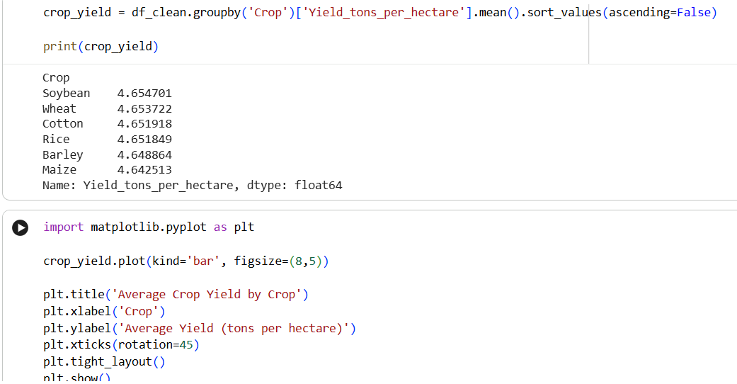
Figure 1: Distribution of Crop Yield
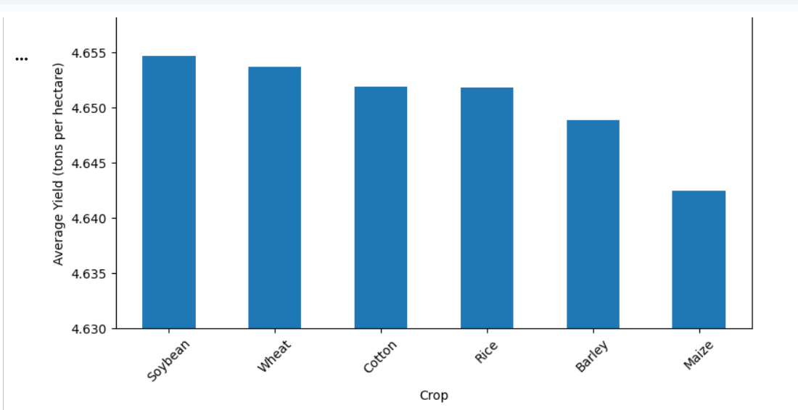

8. Bivariate Analysis
Bivariate analysis examines the relationship between two variables.
For this dataset, scatter plots and correlation coefficients were used for numerical variables, while grouped average comparisons were used for categorical variables.

8.1 Rainfall vs Crop Yield
A scatter plot was used to examine the relationship between rainfall and crop yield.
The correlation coefficient was:
r = 0.7645
This represents a strong positive linear association between rainfall and crop yield in the dataset.
The upward pattern in the scatter plot suggests that higher rainfall values are generally associated with higher crop yields.

Visualization
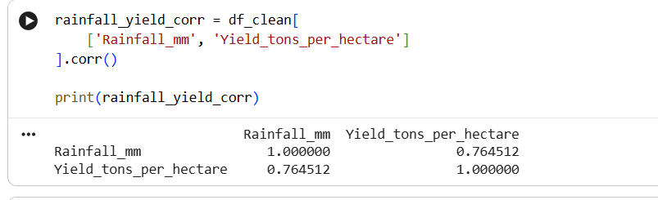
Figure 2: Rainfall vs Crop Yield
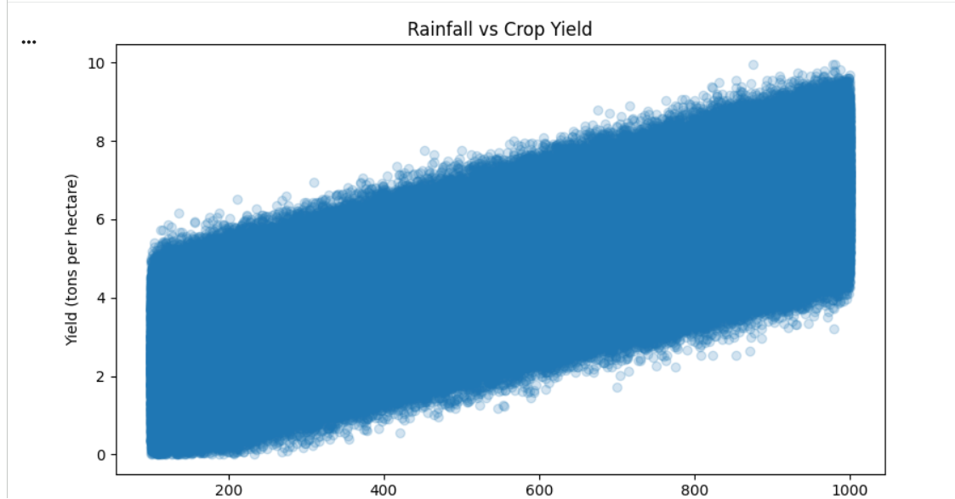

Interpretation
Rainfall is one of the variables showing the strongest numerical association with yield. It may therefore be considered an important candidate variable for further statistical analysis and predictive modelling.
However, correlation does not establish causation. Other agricultural and environmental factors may also influence this relationship.

9. Temperature vs Crop Yield
The relationship between temperature and yield was examined using a scatter plot.
The correlation coefficient was:
r = 0.0852
This indicates a very weak positive linear association.
The low correlation suggests that temperature alone does not have a strong linear relationship with crop yield in this dataset.

Visualization
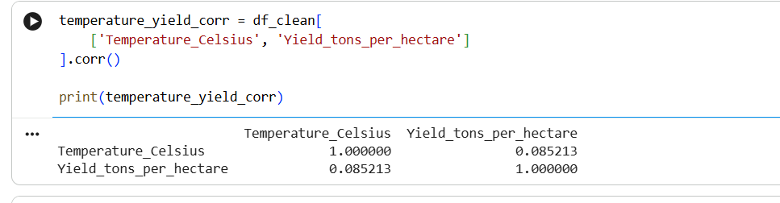
Figure 3: Temperature vs Crop Yield
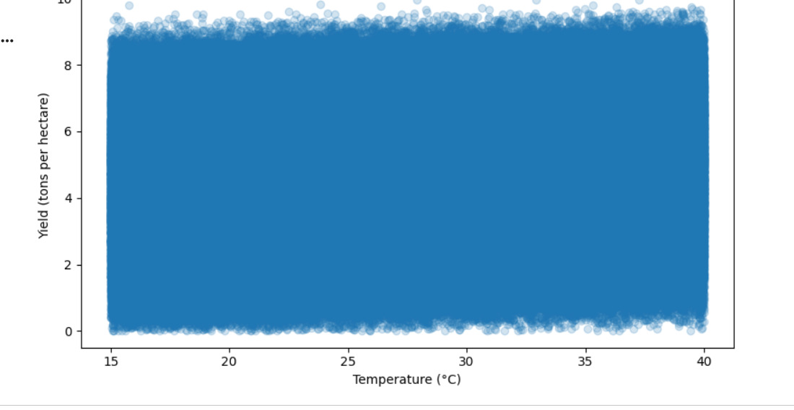

10. Days to Harvest vs Crop Yield
The relationship between days to harvest and crop yield was examined using a scatter plot.
The correlation coefficient was:
r = −0.0026
This value is extremely close to zero and indicates an almost negligible linear relationship.

Visualization

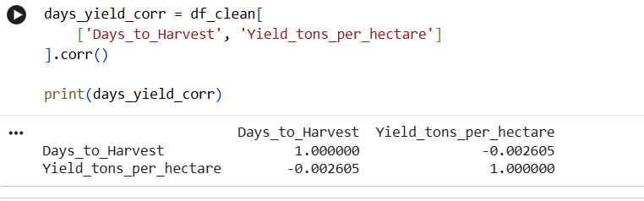
Figure 4: Days to Harvest vs Crop Yield
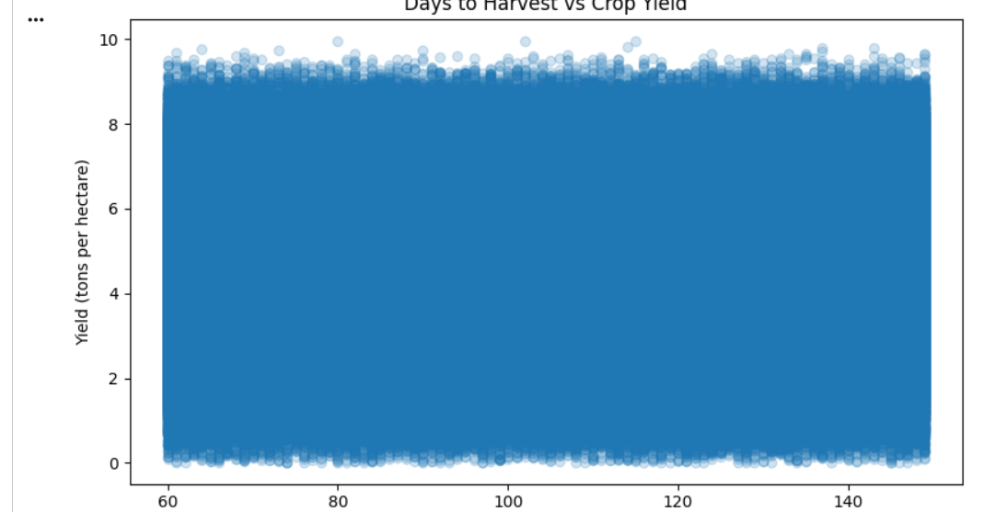

11. Categorical Analysis
Categorical analysis compares the target variable across different groups.
For this dataset, average yield was calculated for:
- Crop
- Region
- Fertilizer usage
- Irrigation usage
- Weather condition
- Soil type
This approach helps determine whether meaningful differences in average yield exist between categories.

12. Average Yield by Crop
The average yield by crop was:
Crop | Average Yield
Soybean | 4.6547
Wheat | 4.6537
Cotton | 4.6519
Rice | 4.6518
Barley | 4.6489
Maize | 4.6425
The differences were very small. Soybean had the highest average yield, while maize had the lowest.
The difference between the highest and lowest averages was approximately 0.0122 tons/hectare.

Visualization

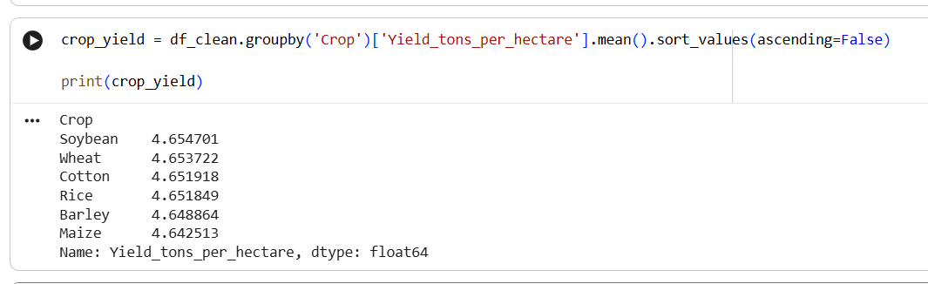
Figure 5: Average Yield by C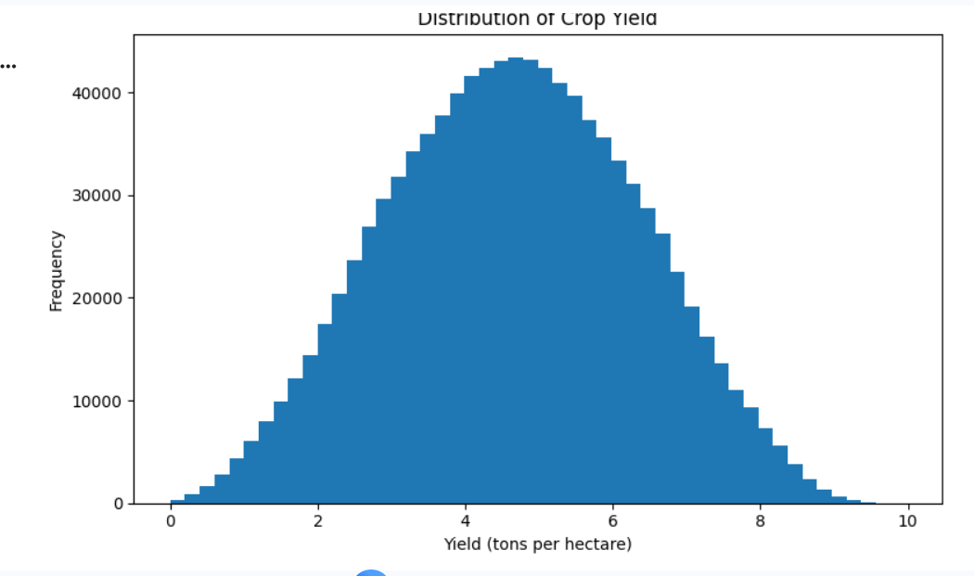rop
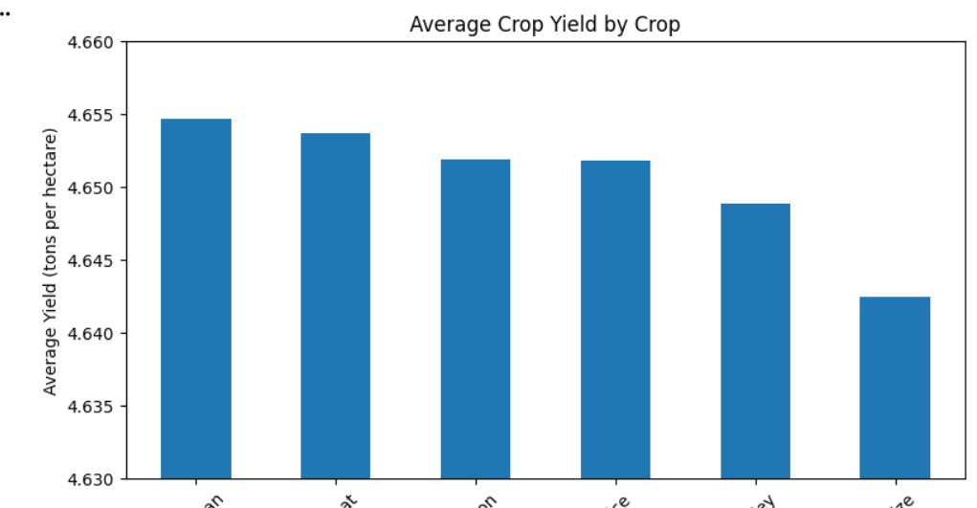

13. Average Yield by Region
The average yield by region was:
Region | Average Yield
North | 4.6553
West | 4.6505
South | 4.6499
East | 4.6467
The difference between the highest and lowest regional averages was approximately 0.0086 tons/hectare, indicating limited variation.

Visualization

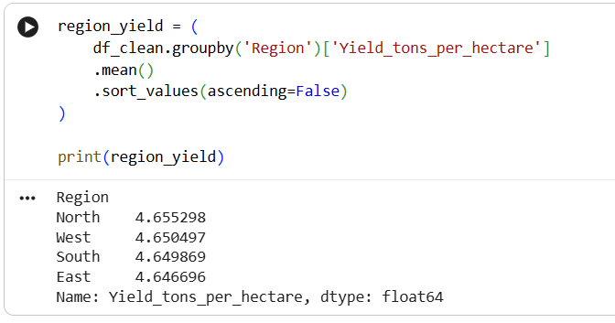
Figure 6: Average Yield by Region
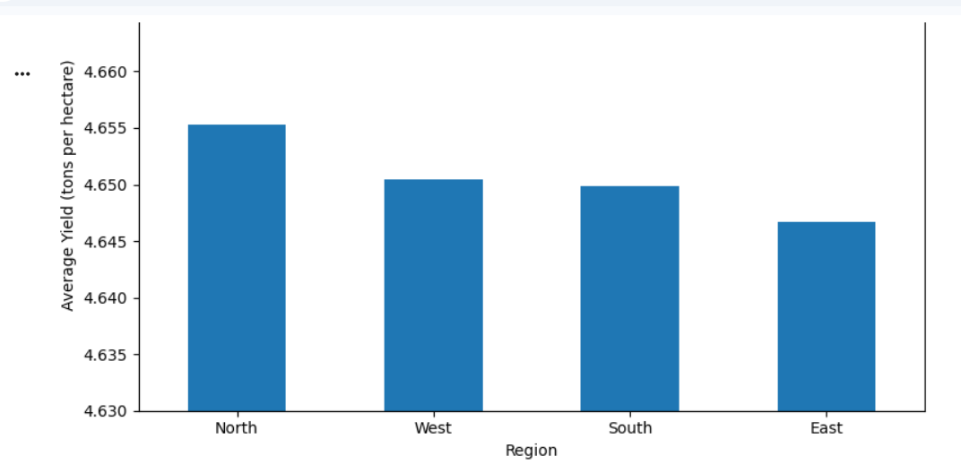

14. Fertilizer Usage vs Crop Yield
Average yield was compared between observations where fertilizer was used and observations where it was not used.
Fertilizer Used | Average Yield
False | 3.9014
True | 5.3996
The difference was approximately 1.4982 tons/hectare.
This is a noticeable difference compared with the small differences observed across crop and regional categories.

Visualization

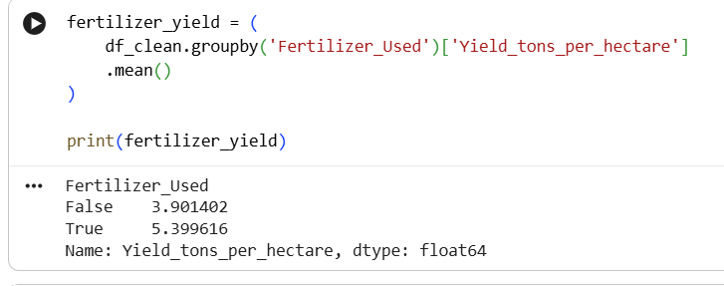
Figure 7: Average Yield by Fertilizer Usage
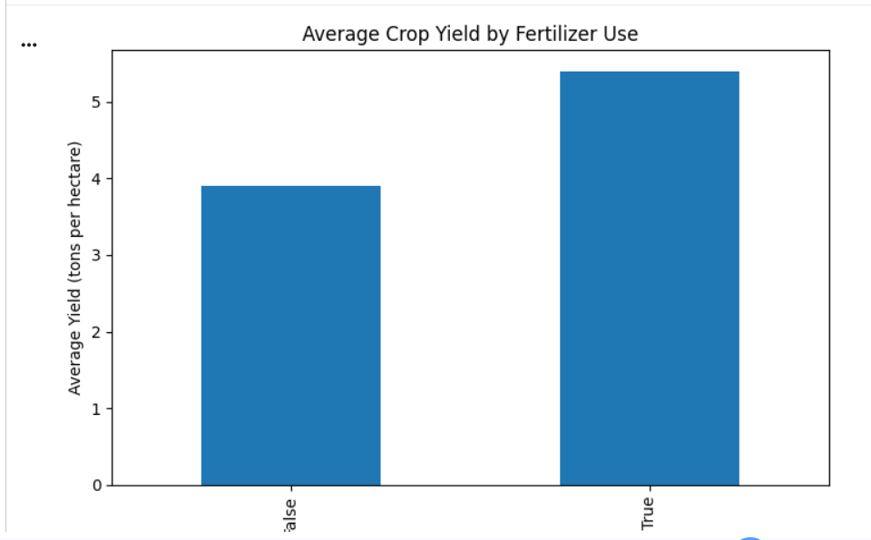
.

Interpretation
Fertilizer usage is associated with higher average yield in this dataset.
However, the dataset only records whether fertilizer was used. It does not record the quantity, type, or application frequency. Therefore, the analysis cannot conclude that increasing fertilizer quantity will necessarily increase yield.

15. Irrigation Usage vs Crop Yield
Average yield was also compared between irrigated and non-irrigated observations.
Irrigation Used | Average Yield
False | 4.0519
True | 5.2502
The difference was approximately 1.1983 tons/hectare.

Visualization

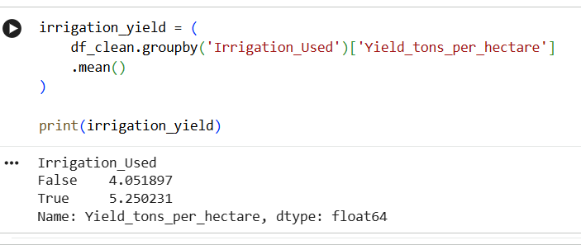
Figure 8: Average Yield by Irrigation Usage
.

Interpretation
Irrigation usage showed a noticeable association with average crop yield.
As with fertilizer, this result represents an association and should not be interpreted as proof of causation.

16. Weather Condition vs Crop Yield
The average yields were:
Weather Condition | Average Yield
Sunny | 4.6532
Rainy | 4.6503
Cloudy | 4.6483
The difference between the highest and lowest averages was approximately 0.0050 tons/hectare.
This indicates very limited variation in average yield across the three weather categories.

Visualization
Figure 9: Average Yield by Weather Condition
. 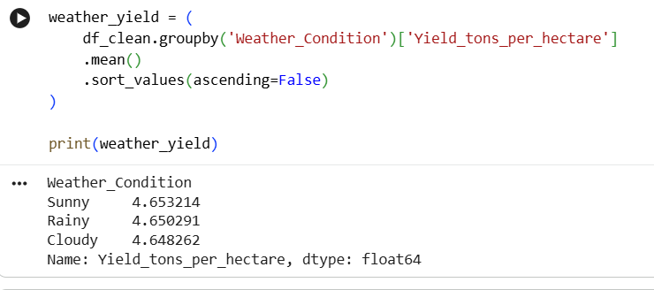
An important observation is that the weather category is different from the numerical rainfall measurement. Although weather categories showed little variation, rainfall amount showed a strong association with yield.

17. Soil Type vs Crop Yield
The average yields by soil type were:
Soil Type | Average Yield
Chalky | 4.6542
Loam | 4.6522
Peaty | 4.6520
Sandy | 4.6496
Silt | 4.6495
Clay | 4.6461
The difference between the highest and lowest averages was approximately 0.0081 tons/hectare.
Therefore, soil type showed limited variation in average yield within this dataset.

Visualization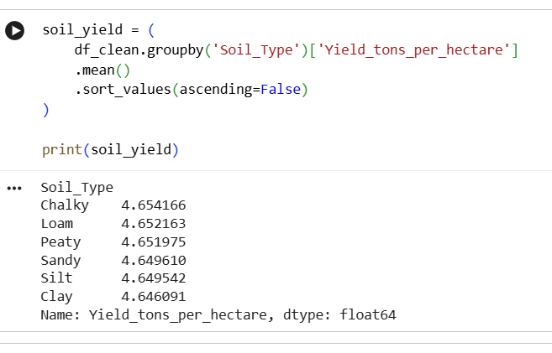

Figure 10: Average Yield by Soil Type

18. Correlation Analysis
Correlation analysis is used to measure the strength and direction of linear relationships between numerical variables.
For this project, particular attention was given to the relationship between numerical variables and the target variable.
Variable | Correlation with Yield | Interpretation
Rainfall | 0.7645 | Strong positive
Temperature | 0.0852 | Very weak positive
Days to Harvest | -0.0026 | Negligible
The results suggest that rainfall is substantially more strongly associated with yield than temperature or days to harvest.
Correlation values should be interpreted carefully because they measure linear association and do not establish causation.
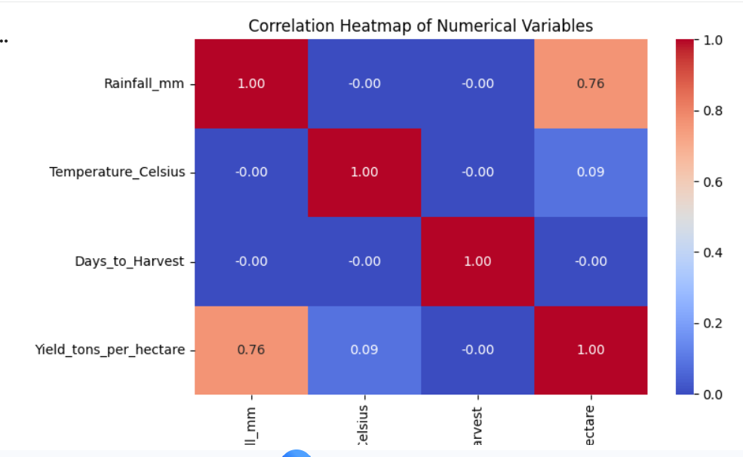

19. Statistical Anomalies and Outlier Handling
Anomalies and outliers are important considerations in EDA because extreme observations may influence statistical summaries and visualizations.
During the previous data-cleaning stage, 231 negative yield observations were identified and removed because negative crop yield is not physically meaningful.
After cleaning, the minimum yield was approximately 0.0004 tons/hectare.
An IQR-based analysis identified 84 statistical outliers in the yield variable.
These observations were not automatically removed because an outlier is not necessarily an error. A very high positive yield may represent a legitimate agricultural observation.
Therefore, the statistical outliers were retained unless additional domain evidence suggested that they were incorrect.
This approach avoids unnecessary removal of potentially meaningful observations.

20. Visualization Strategy
Different visualization techniques were selected according to the type of question being answered.
Analytical Question | Recommended Visualization | Purpose
What is the distribution of yield? | Histogram | Understand distribution
Does rainfall relate to yield? | Scatter plot | Examine numerical relationship
Does temperature relate to yield? | Scatter plot | Examine numerical relationship
Do crops differ in average yield? | Bar chart | Compare categories
Do regions differ in average yield? | Bar chart | Compare regions
Does fertilizer usage differ in yield? | Bar chart | Compare usage groups
Does irrigation usage differ in yield? | Bar chart | Compare usage groups
Does soil type differ in yield? | Bar chart | Compare categories
Does weather condition differ in yield? | Bar chart | Compare categories
The selected visualizations are simple and interpretable, making them suitable for both technical and non-technical stakeholders.

21. Key EDA Findings
The analysis produced the following major findings:

Finding 1: Rainfall showed the strongest numerical association
Rainfall had a correlation of 0.7645 with crop yield, representing a strong positive linear association.

Finding 2: Fertilizer usage showed a noticeable difference
Average yield was approximately:
- 3.9014 tons/hectare without fertilizer
- 5.3996 tons/hectare with fertilizer

Finding 3: Irrigation usage showed a noticeable difference
Average yield was approximately:
- 4.0519 tons/hectare without irrigation
- 5.2502 tons/hectare with irrigation

Finding 4: Temperature showed a weak relationship
The correlation between temperature and yield was only 0.0852.

Finding 5: Days to harvest showed almost no linear relationship
The correlation was −0.0026, which is effectively negligible.

Finding 6: Several categorical variables showed limited variation
Crop, region, soil type, and weather condition showed only small differences in average yield.

22. Business Interpretation
The EDA findings can support several potential agribusiness decisions.

Agricultural Resource Planning
The noticeable association between irrigation usage and yield suggests that water-management variables may deserve attention in future agricultural planning.

Fertilizer Management
The difference between fertilizer-use groups indicates that fertilizer-related information may be useful for further analysis. However, future datasets should ideally include fertilizer quantity, type, and application timing.

Weather and Rainfall Monitoring
The strong rainfall-yield association suggests that rainfall information may be valuable for crop-yield forecasting and agricultural planning.

Predictive Modelling
Rainfall, fertilizer usage, and irrigation usage may be useful candidate features for future crop-yield prediction models.
However, additional analysis is required before making operational decisions because the current EDA identifies associations rather than causal relationships.

23. Recommendations for Further Analysis
Based on the EDA, the following activities are recommended:
- Develop a regression model to predict crop yield.
- Compare multiple machine learning algorithms.
- Examine feature importance.
- Investigate interactions between rainfall, irrigation, fertilizer, and crop type.
- Apply appropriate encoding techniques to categorical variables.
- Evaluate model performance using MAE, RMSE, and R-squared.
- Perform cross-validation to assess model reliability.
- Investigate whether non-linear relationships exist.
- Collect additional agricultural variables such as fertilizer quantity, soil nutrients, farm size, and irrigation intensity.
- Validate the findings using additional datasets.

24. Limitations
The current EDA has several limitations:
- The analysis identifies associations rather than causal relationships.
- Fertilizer and irrigation are recorded only as usage indicators.
- The dataset does not provide detailed information about fertilizer quantity or irrigation volume.
- Important agricultural variables may not be present.
- Correlation measures primarily capture linear relationships.
- Average comparisons do not control for interactions between variables.
- The analysis is based on one dataset and therefore should not automatically be generalized to all agricultural regions or farming systems.

25. Reproducibility and Documentation Strategy
To ensure that the analysis can be repeated and verified, the Python analysis should be maintained in a structured Jupyter Notebook.
The notebook should contain:
- Dataset loading
- Dataset inspection
- Descriptive statistics
- Data-quality checks
- EDA calculations
- Correlation analysis
- Visualization code
- Key findings
- Interpretation
The cleaned CSV dataset and EDA notebook should be maintained alongside the report in the GitHub project repository.
A clear folder structure can be used:
Week-1/
→ Week 1 report
Week-2/
→ Week 2 report
→ Cleaned dataset
Week-3/
→ EDA report
→ EDA Python notebook
This makes the analysis easier to reproduce and allows another person to understand how the reported findings were generated.

26. Conclusion
The EDA framework developed in this report provides a structured approach for transforming agricultural data into meaningful insights.
The practical analysis demonstrated the use of descriptive statistics, histograms, scatter plots, correlation analysis, grouped averages, and categorical comparisons.
Among the variables examined, rainfall showed the strongest numerical association with crop yield, while fertilizer and irrigation usage showed noticeable differences in average yield. Temperature and days to harvest showed weak or negligible linear relationships, and several categorical variables showed limited variation.
The EDA therefore provides a foundation for selecting candidate features and developing a predictive modelling framework in the next stage of the internship.
Most importantly, the analysis demonstrates that EDA is not simply about creating charts. It involves asking analytical questions, selecting appropriate methods, interpreting statistical results, identifying limitations, and converting findings into meaningful business insights.

27. Tools Used
- Python
- Pandas
- Matplotlib
- Jupyter Notebook / Google Colab
- CSV Dataset
- GitHub

28. Deliverables
The Week 3 project consists of:
- Exploratory Data Analysis Report
- Python EDA Notebook
- Cleaned Agricultural Dataset
- EDA Visualizations
- GitHub Project Repository

